Test Case: tc010_SPX_Dev5_Validacion_Agregar_Remover_Articulos_Controlados
Step 1 - Enter username and password and click to button Enter : Credentials Entered
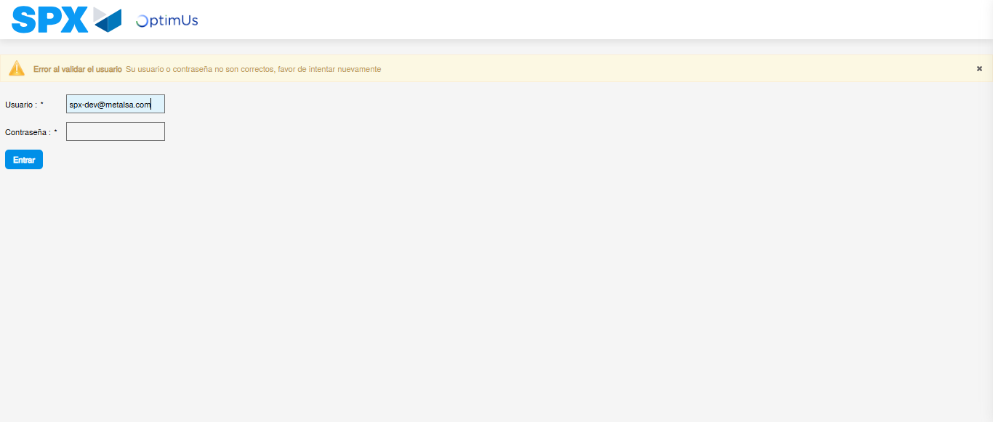Image file-name: QC_Testing-runTestMultipleTimes-nov. 20 2025, 02 21 09 p. m.

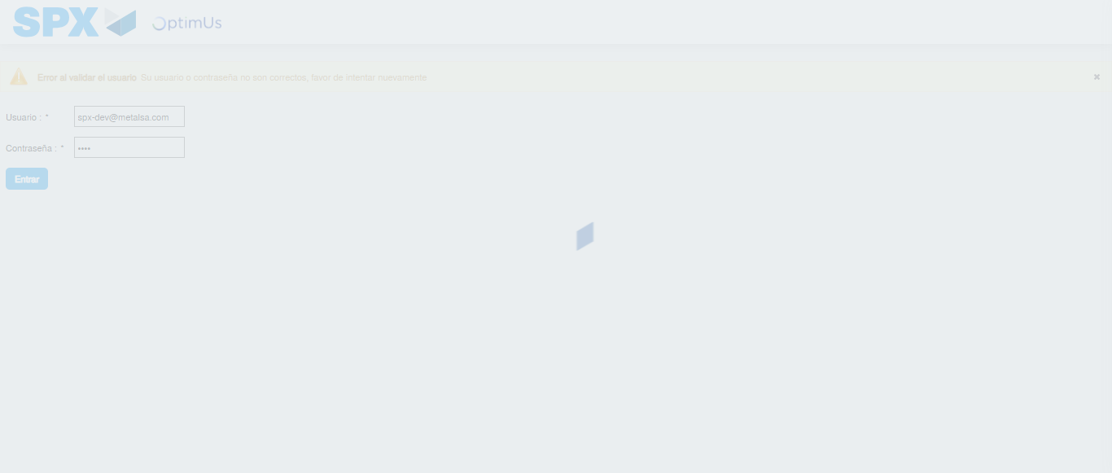Image file-name: QC_Testing-runTestMultipleTimes-nov. 20 2025, 02 21 10 p. m.

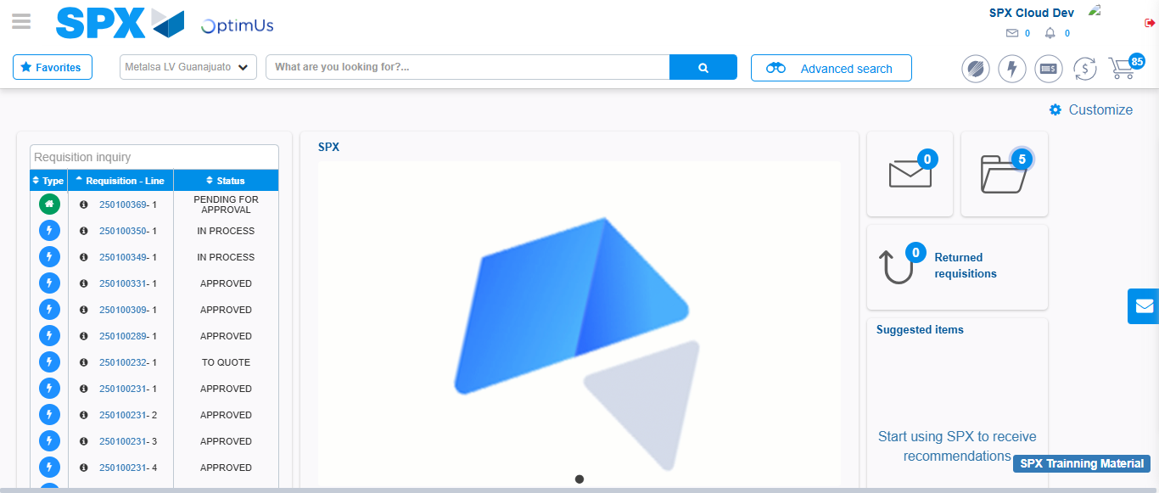Image file-name: QC_Testing-tc001_SPX_Dev5_Validar_Filtro_Campo_MenuName_Administrador_Roles_Menu-nov. 20 2025, 02 21 39 p. m.

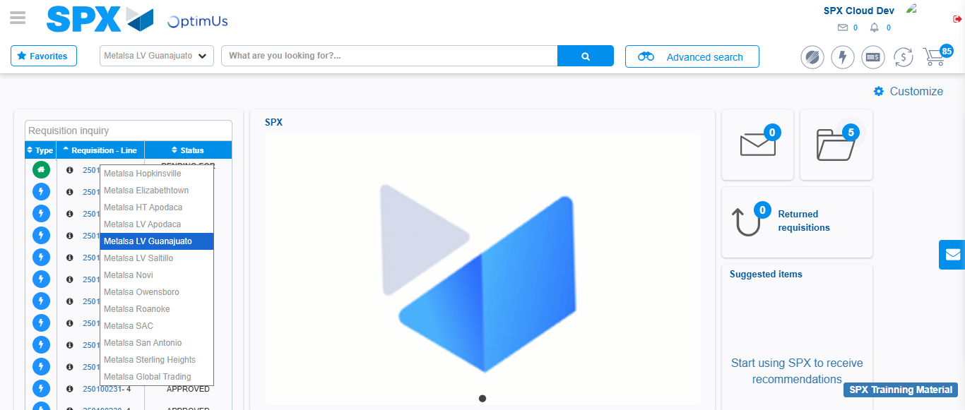Image file-name: QC_Testing-tc002_SPX_Dev5_Validar_Filtro_Campo_URLPath_Administrador_Roles_Menu-nov. 20 2025, 02 22 01 p. m.

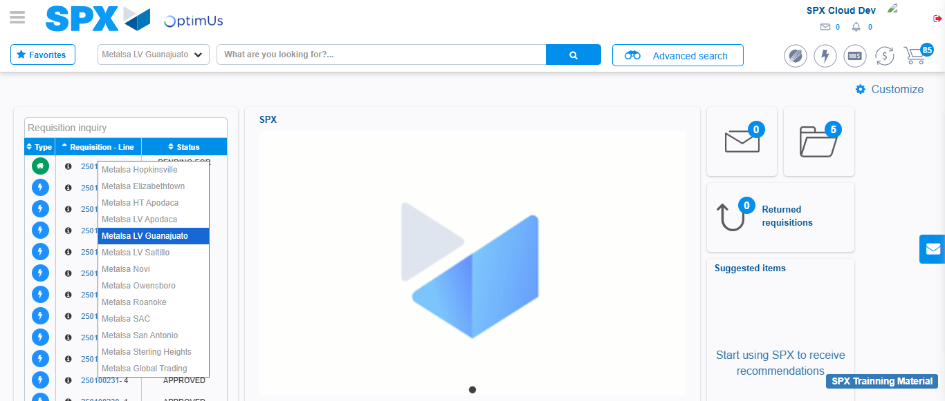Image file-name: QC_Testing-tc003_SPX_Dev5_Validar_Funcionalidad_Botones_Add_Remove_Administrador_Roles_Menu-nov. 20 2025, 02 22 23 p. m.

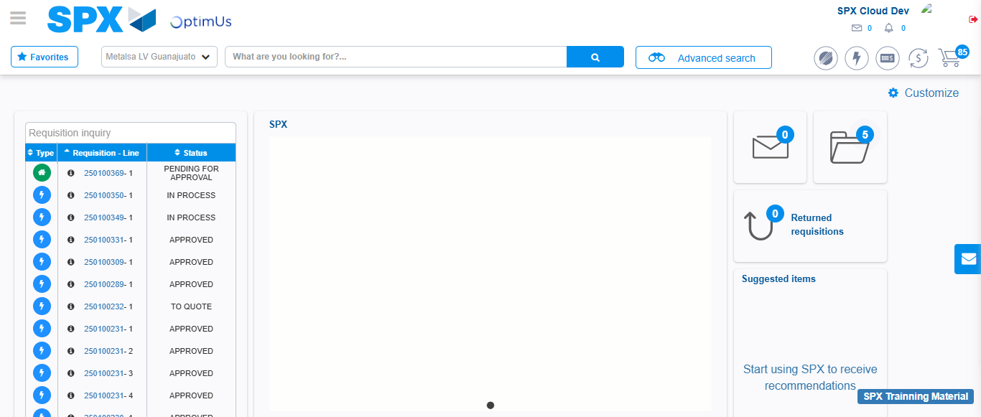Image file-name: QC_Testing-tc004_SPX_Dev5_Validacion_Filtro_Campo_MenuName_Administrador_Menu-nov. 20 2025, 02 22 49 p. m.

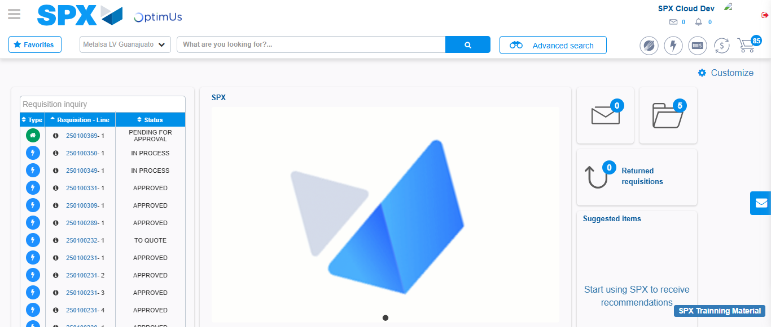Image file-name: QC_Testing-tc005_SPX_Dev5_Validacion_Filtro_Campo_URLPath_Administrador_Menu-nov. 20 2025, 02 23 11 p. m.

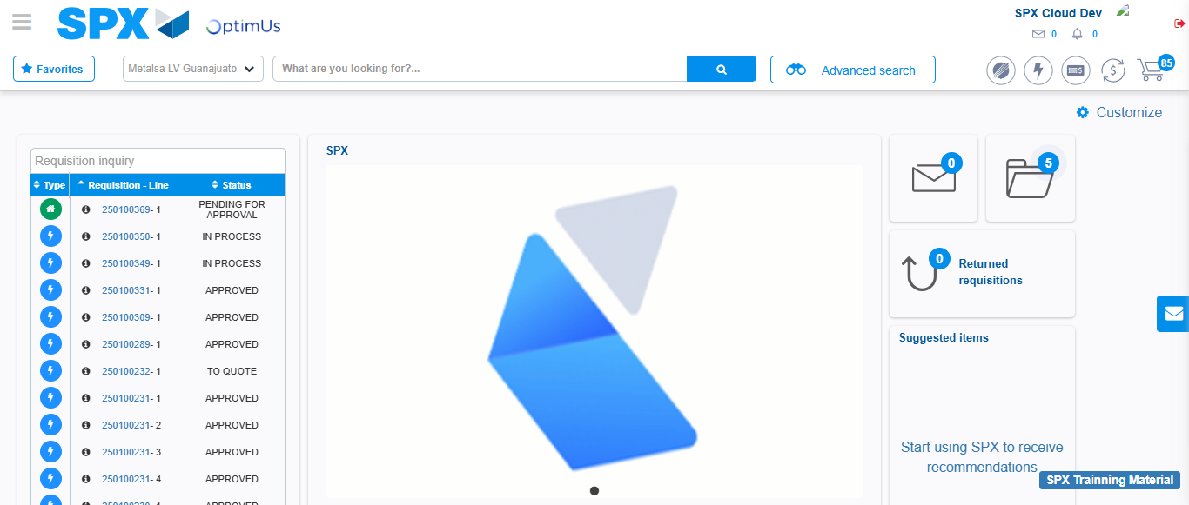Image file-name: QC_Testing-tc006_SPX_Dev5_Validacion_Boton_AddNewMenu_Administrador_Menu-nov. 20 2025, 02 23 36 p. m.

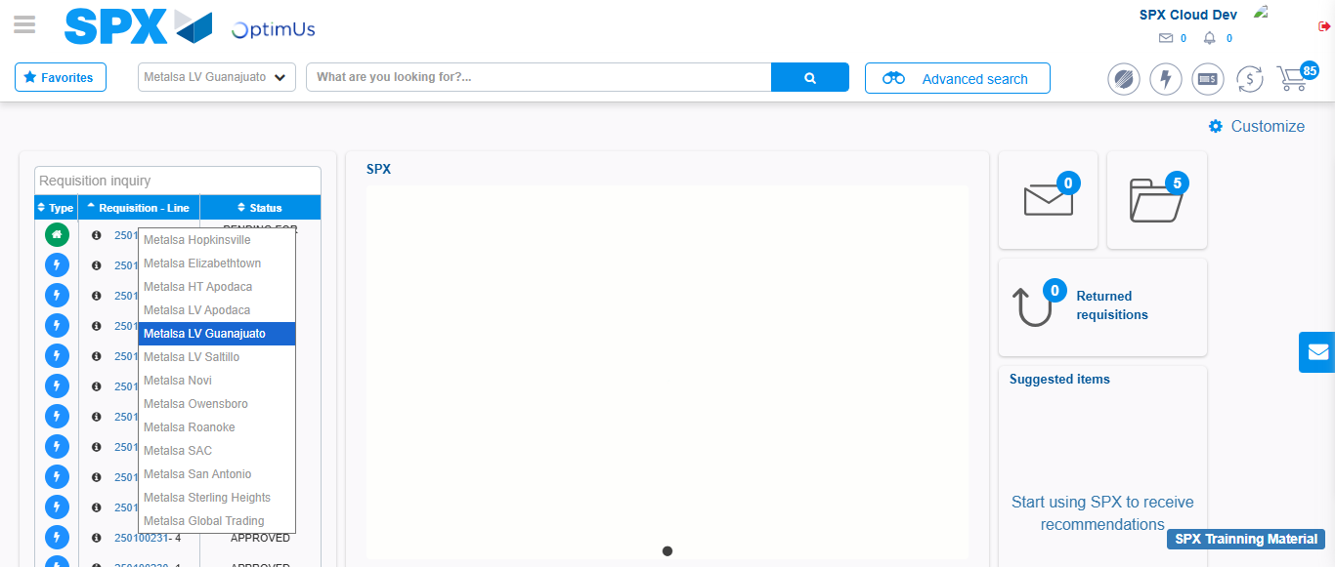Image file-name: QC_Testing-tc007_SPX_Dev5_Validacion_Boton_Edit_Administrador_Menu-nov. 20 2025, 02 24 00 p. m.

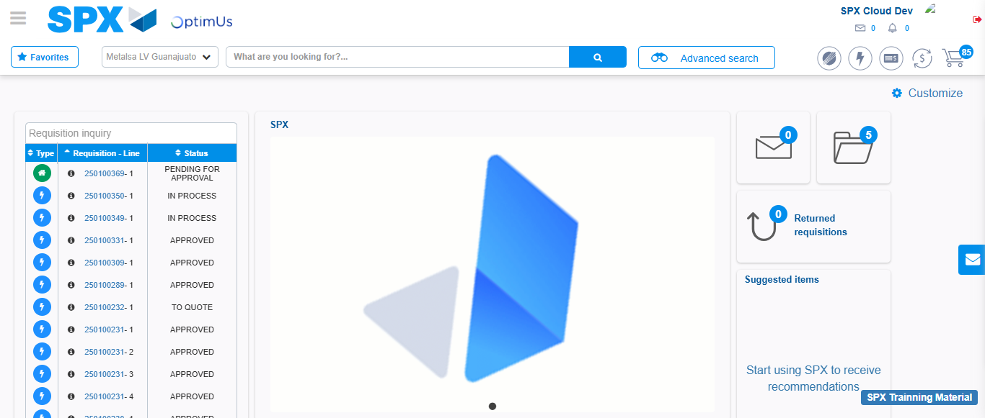Image file-name: QC_Testing-tc008_SPX_Dev5_Validacion_Boton_Remove_Administrador_Menu-nov. 20 2025, 02 24 29 p. m.

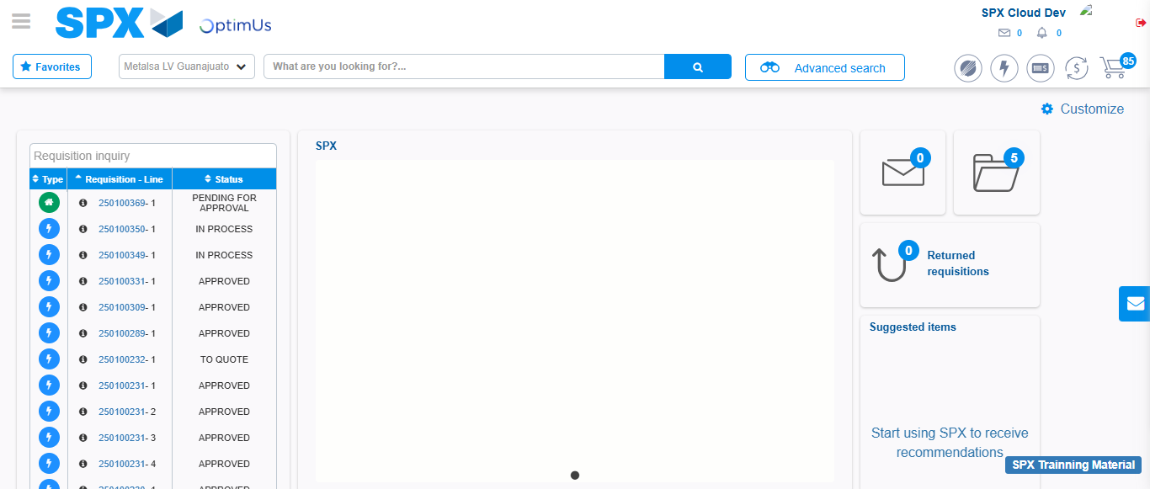Image file-name: QC_Testing-tc009_SPX_Dev5_Validacion_Campos_Busqueda_Articulos_Controlados-nov. 20 2025, 02 24 54 p. m.

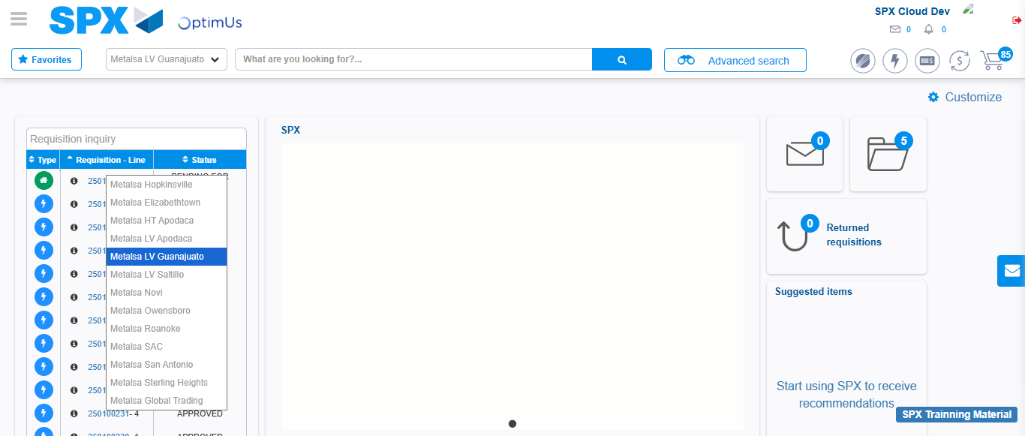Image file-name: QC_Testing-tc010_SPX_Dev5_Validacion_Agregar_Remover_Articulos_Controlados-nov. 20 2025, 02 25 40 p. m.

Step 2 - Select to UEN and Access to Articulos Controlados: UEN Correctly selected and Correct access
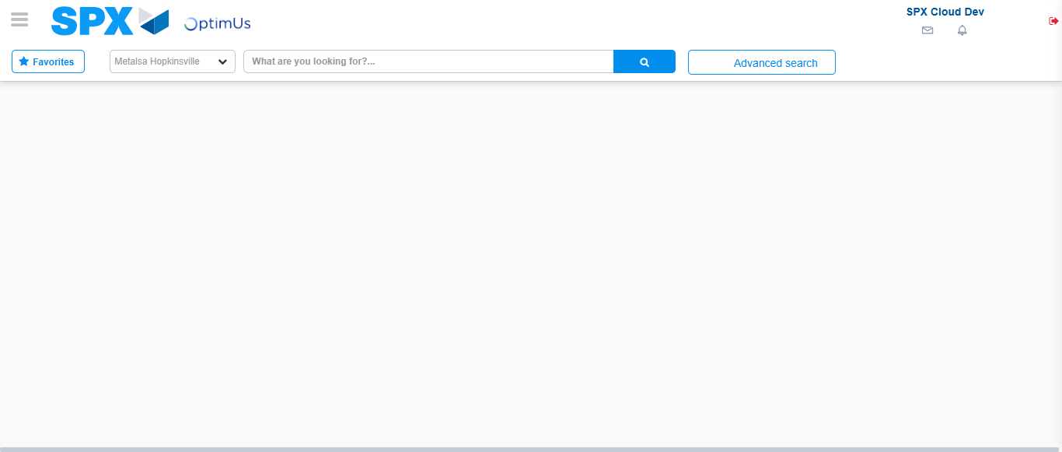Image file-name: QC_Testing-runTestMultipleTimes-nov. 20 2025, 02 21 13 p. m.

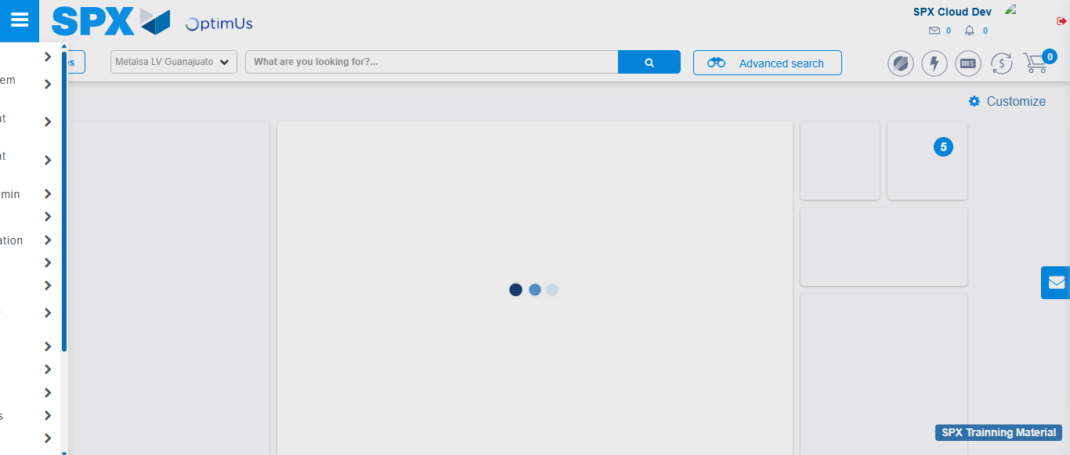Image file-name: QC_Testing-runTestMultipleTimes-nov. 20 2025, 02 21 14 p. m.

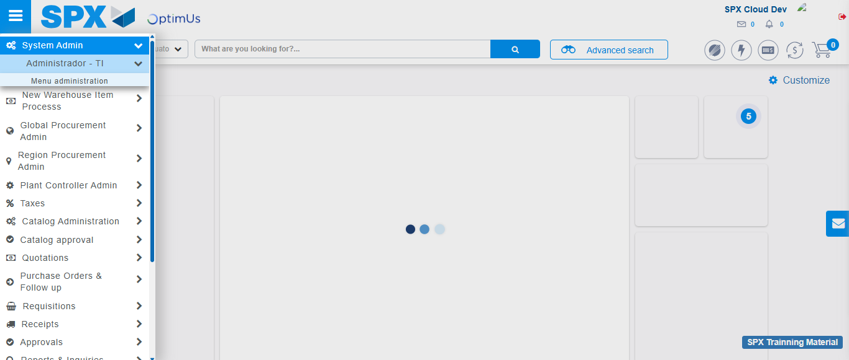Image file-name: QC_Testing-runTestMultipleTimes-nov. 20 2025, 02 21 15 p. m.

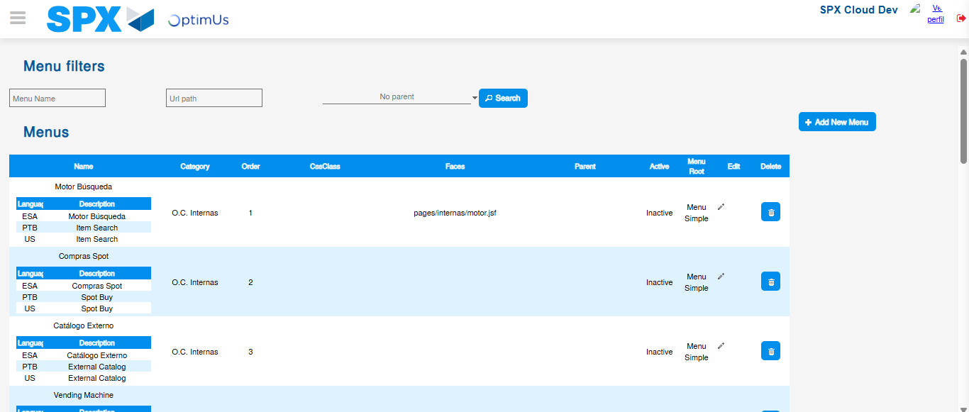Image file-name: QC_Testing-runTestMultipleTimes-nov. 20 2025, 02 21 20 p. m.

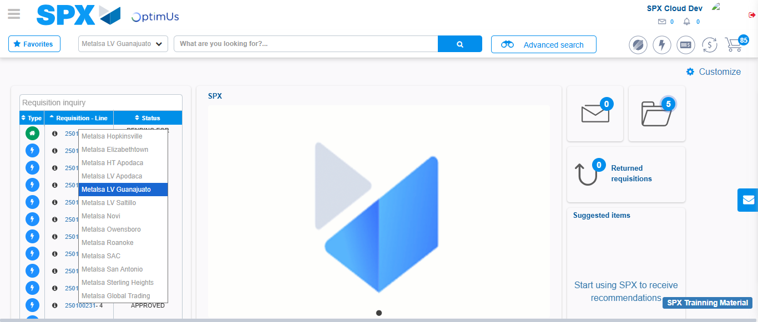Image file-name: QC_Testing-tc001_SPX_Dev5_Validar_Filtro_Campo_MenuName_Administrador_Roles_Menu-nov. 20 2025, 02 21 40 p. m.

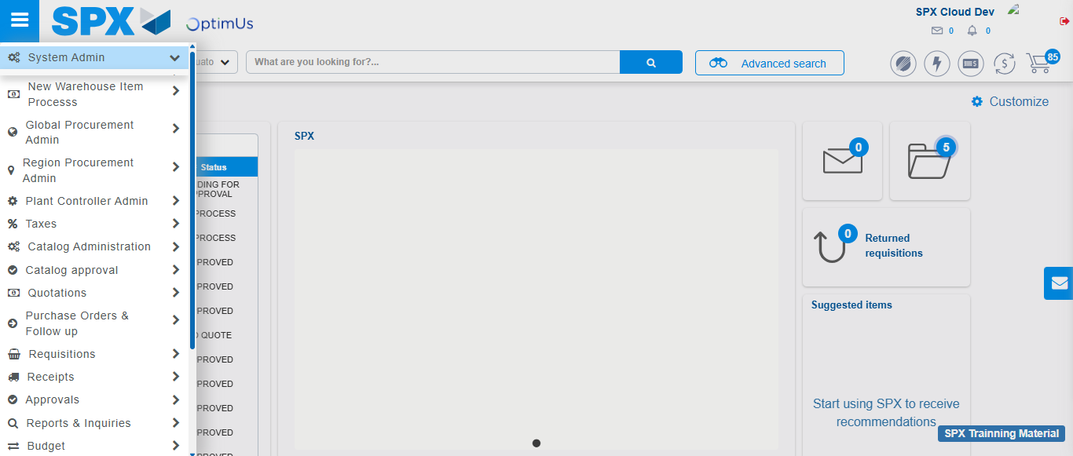Image file-name: QC_Testing-tc001_SPX_Dev5_Validar_Filtro_Campo_MenuName_Administrador_Roles_Menu-nov. 20 2025, 02 21 41 p. m.

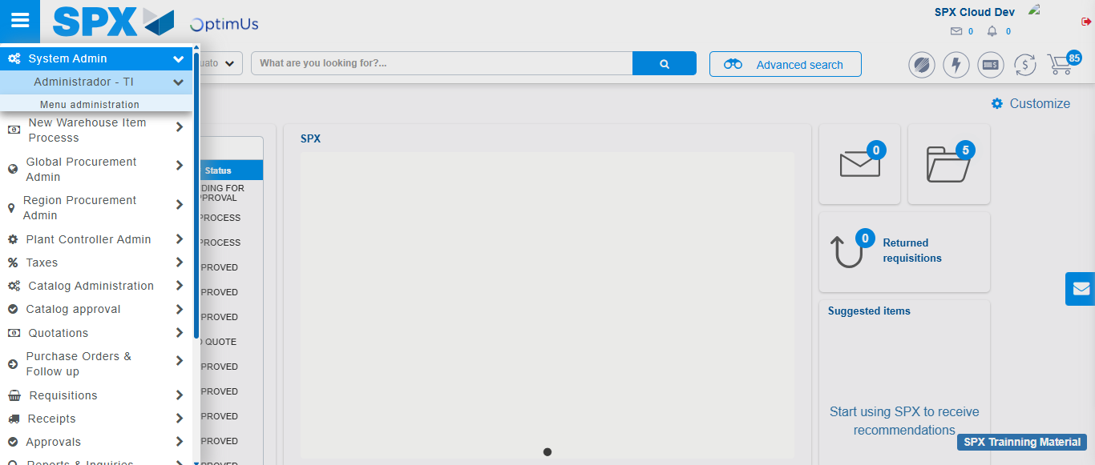Image file-name: QC_Testing-tc001_SPX_Dev5_Validar_Filtro_Campo_MenuName_Administrador_Roles_Menu-nov. 20 2025, 02 21 42 p. m.

Image file-name: QC_Testing-tc001_SPX_Dev5_Validar_Filtro_Campo_MenuName_Administrador_Roles_Menu-nov. 20 2025, 02 21 43 p. m.

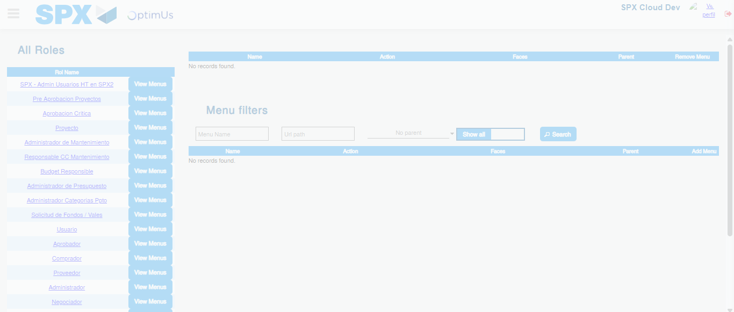Image file-name: QC_Testing-tc001_SPX_Dev5_Validar_Filtro_Campo_MenuName_Administrador_Roles_Menu-nov. 20 2025, 02 21 44 p. m.

Image file-name: QC_Testing-tc002_SPX_Dev5_Validar_Filtro_Campo_URLPath_Administrador_Roles_Menu-nov. 20 2025, 02 22 01 p. m.

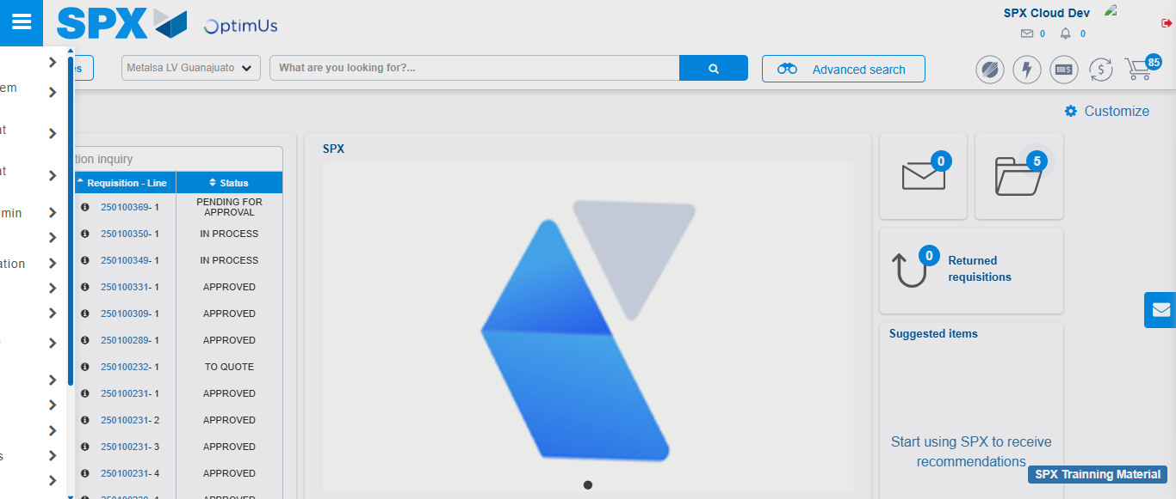Image file-name: QC_Testing-tc002_SPX_Dev5_Validar_Filtro_Campo_URLPath_Administrador_Roles_Menu-nov. 20 2025, 02 22 02 p. m.

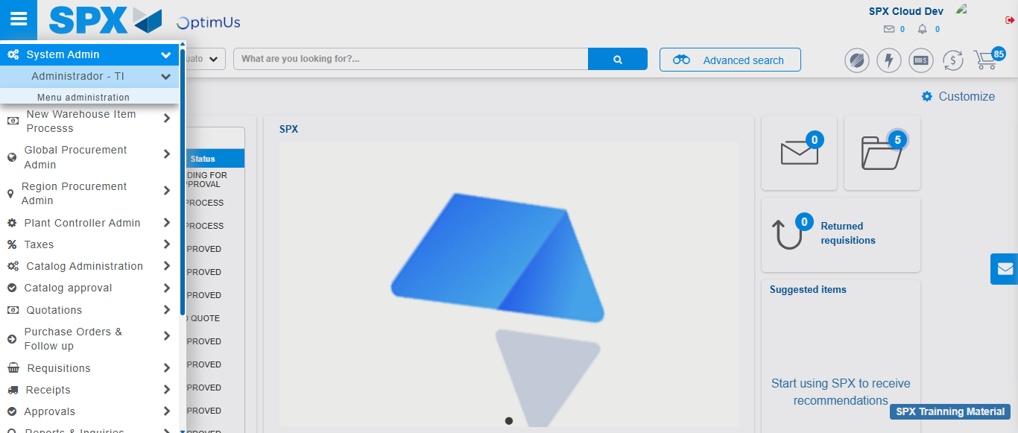Image file-name: QC_Testing-tc002_SPX_Dev5_Validar_Filtro_Campo_URLPath_Administrador_Roles_Menu-nov. 20 2025, 02 22 03 p. m.

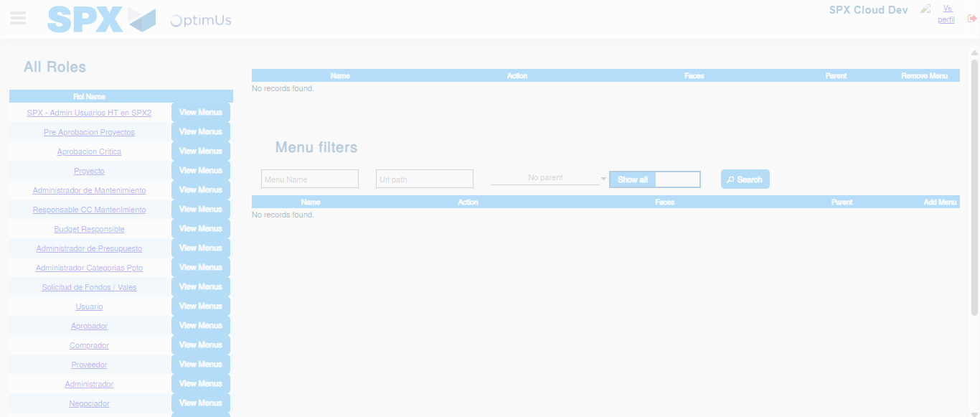Image file-name: QC_Testing-tc002_SPX_Dev5_Validar_Filtro_Campo_URLPath_Administrador_Roles_Menu-nov. 20 2025, 02 22 05 p. m.

Image file-name: QC_Testing-tc003_SPX_Dev5_Validar_Funcionalidad_Botones_Add_Remove_Administrador_Roles_Menu-nov. 20 2025, 02 22 23 p. m.

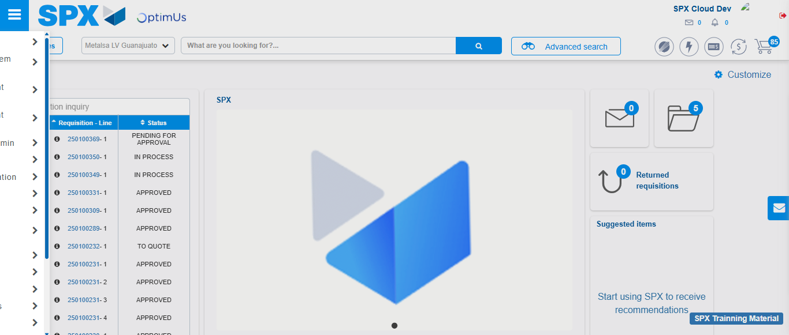Image file-name: QC_Testing-tc003_SPX_Dev5_Validar_Funcionalidad_Botones_Add_Remove_Administrador_Roles_Menu-nov. 20 2025, 02 22 24 p. m.

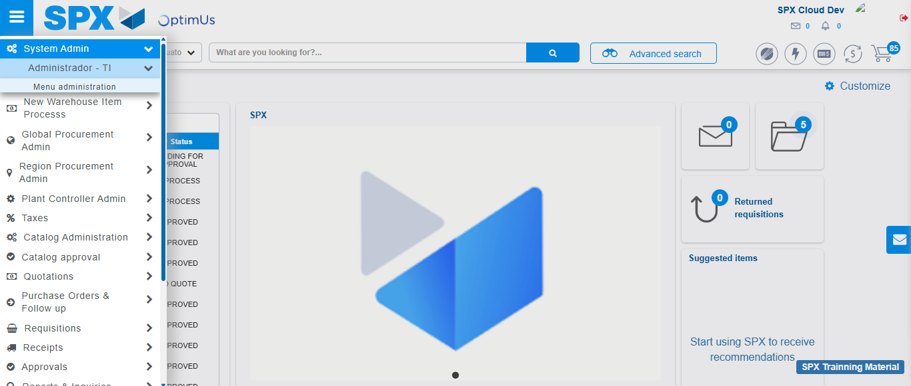Image file-name: QC_Testing-tc003_SPX_Dev5_Validar_Funcionalidad_Botones_Add_Remove_Administrador_Roles_Menu-nov. 20 2025, 02 22 25 p. m.

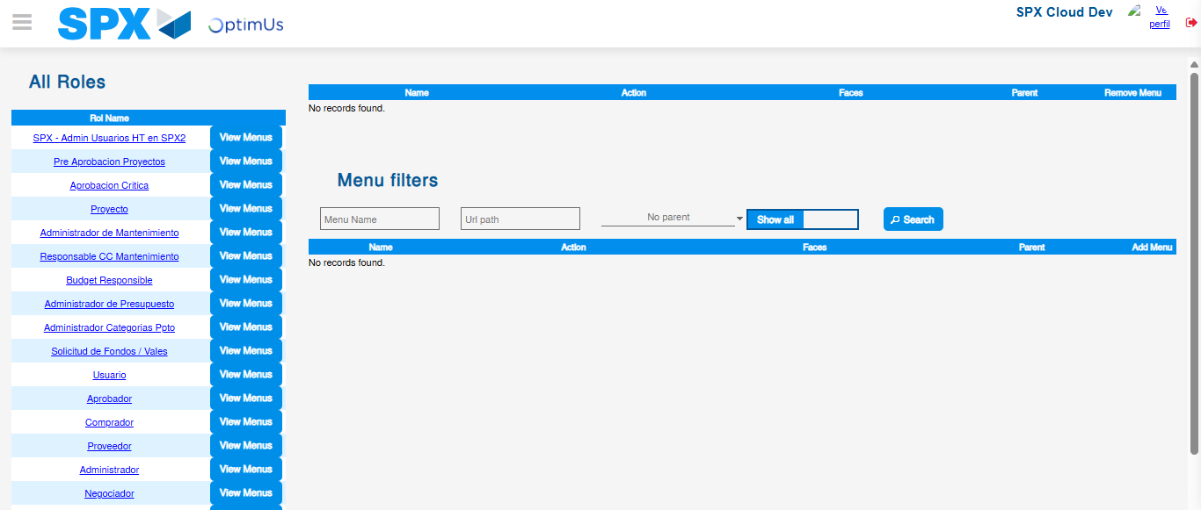Image file-name: QC_Testing-tc003_SPX_Dev5_Validar_Funcionalidad_Botones_Add_Remove_Administrador_Roles_Menu-nov. 20 2025, 02 22 26 p. m.

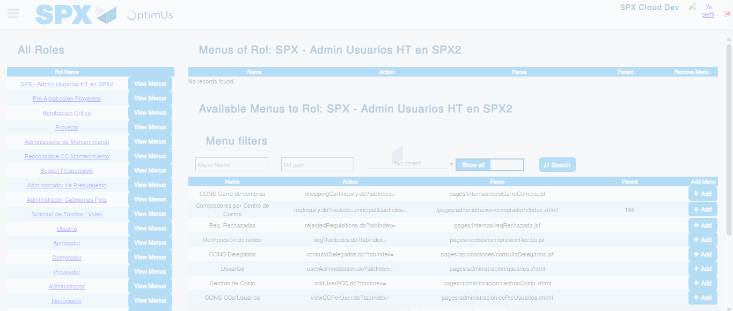Image file-name: QC_Testing-tc003_SPX_Dev5_Validar_Funcionalidad_Botones_Add_Remove_Administrador_Roles_Menu-nov. 20 2025, 02 22 27 p. m.

Image file-name: QC_Testing-tc004_SPX_Dev5_Validacion_Filtro_Campo_MenuName_Administrador_Menu-nov. 20 2025, 02 22 49 p. m.

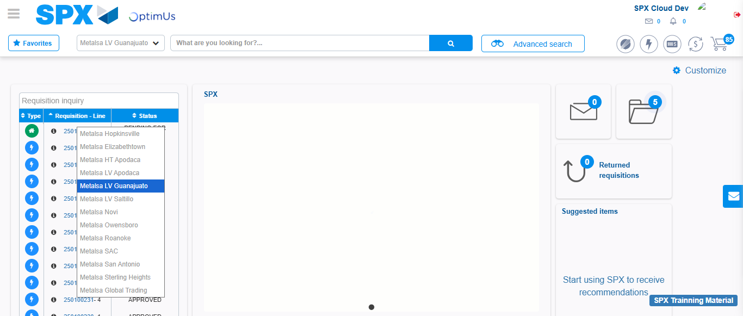Image file-name: QC_Testing-tc004_SPX_Dev5_Validacion_Filtro_Campo_MenuName_Administrador_Menu-nov. 20 2025, 02 22 50 p. m.

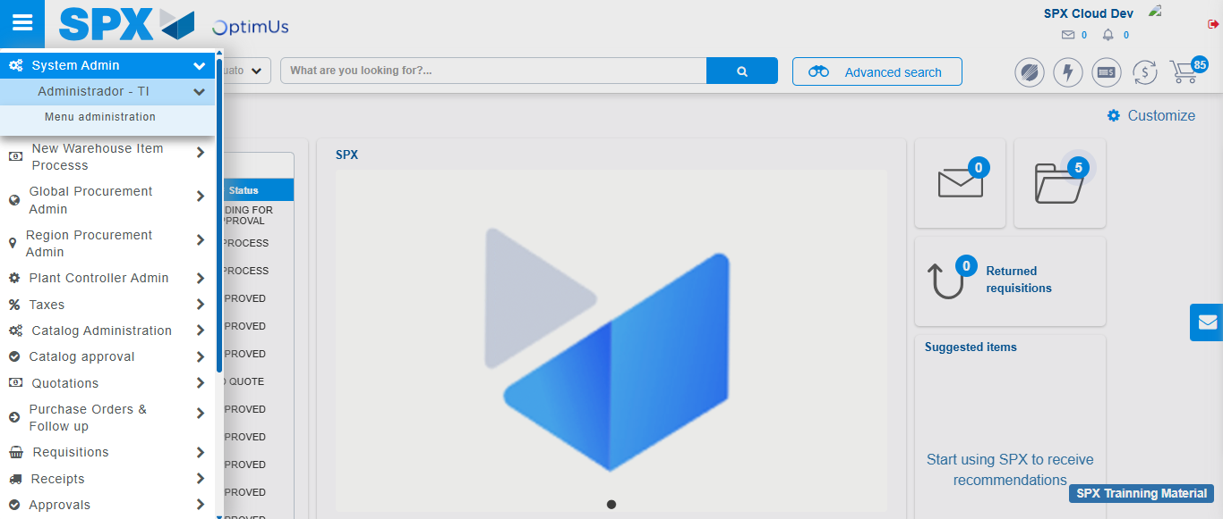Image file-name: QC_Testing-tc004_SPX_Dev5_Validacion_Filtro_Campo_MenuName_Administrador_Menu-nov. 20 2025, 02 22 51 p. m.

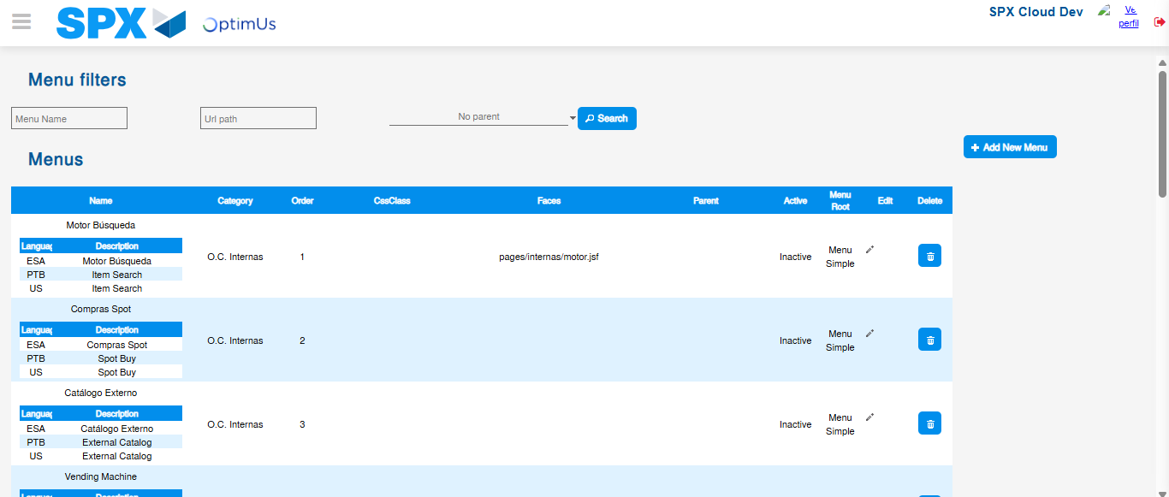Image file-name: QC_Testing-tc004_SPX_Dev5_Validacion_Filtro_Campo_MenuName_Administrador_Menu-nov. 20 2025, 02 22 54 p. m.

Image file-name: QC_Testing-tc005_SPX_Dev5_Validacion_Filtro_Campo_URLPath_Administrador_Menu-nov. 20 2025, 02 23 11 p. m.

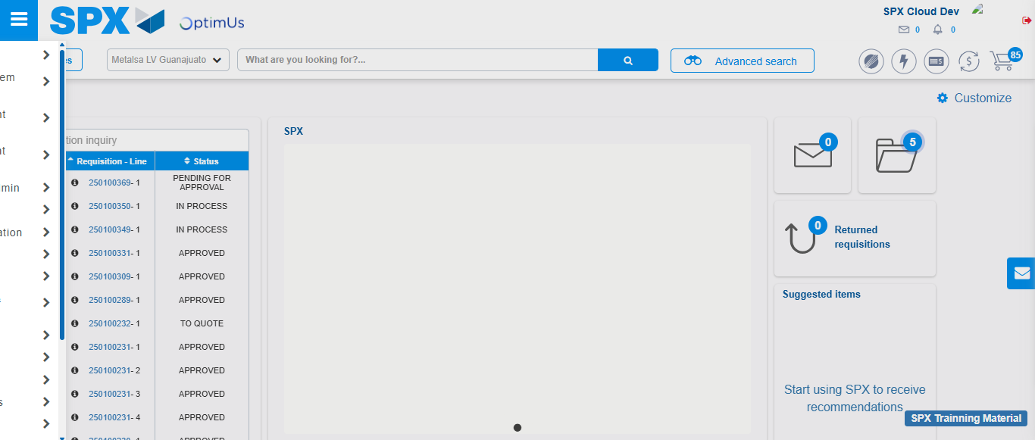Image file-name: QC_Testing-tc005_SPX_Dev5_Validacion_Filtro_Campo_URLPath_Administrador_Menu-nov. 20 2025, 02 23 12 p. m.

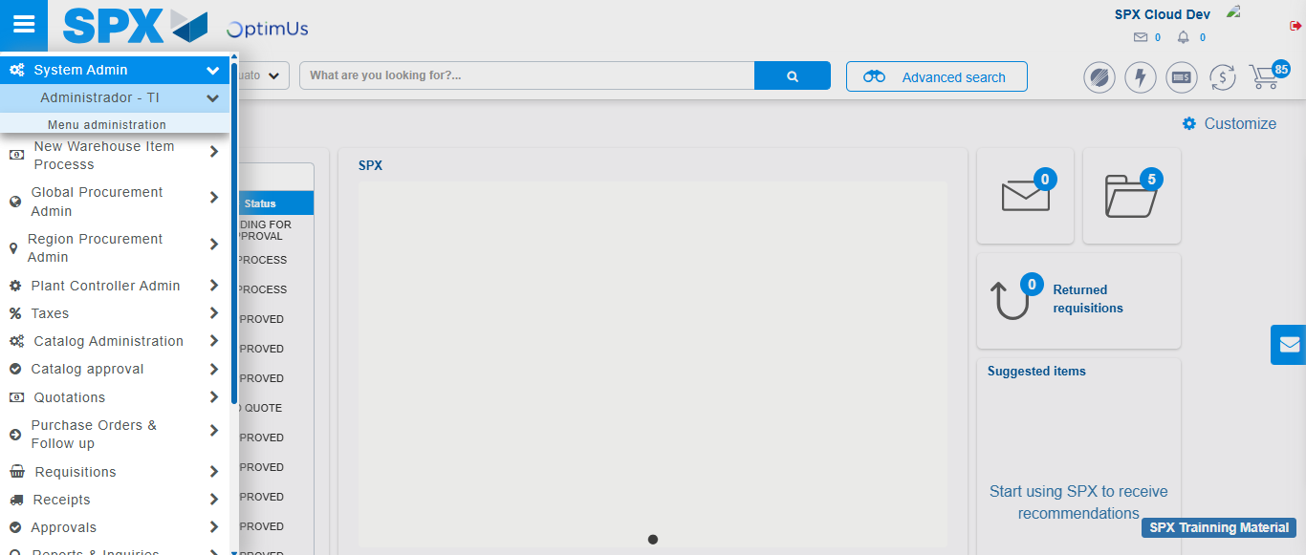Image file-name: QC_Testing-tc005_SPX_Dev5_Validacion_Filtro_Campo_URLPath_Administrador_Menu-nov. 20 2025, 02 23 13 p. m.

Image file-name: QC_Testing-tc005_SPX_Dev5_Validacion_Filtro_Campo_URLPath_Administrador_Menu-nov. 20 2025, 02 23 17 p. m.

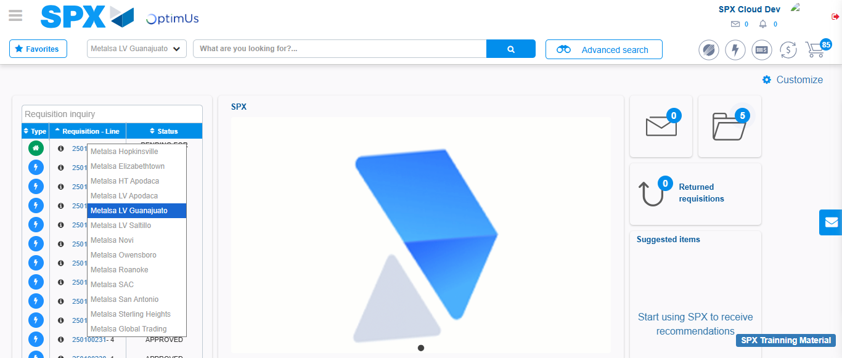Image file-name: QC_Testing-tc006_SPX_Dev5_Validacion_Boton_AddNewMenu_Administrador_Menu-nov. 20 2025, 02 23 37 p. m.

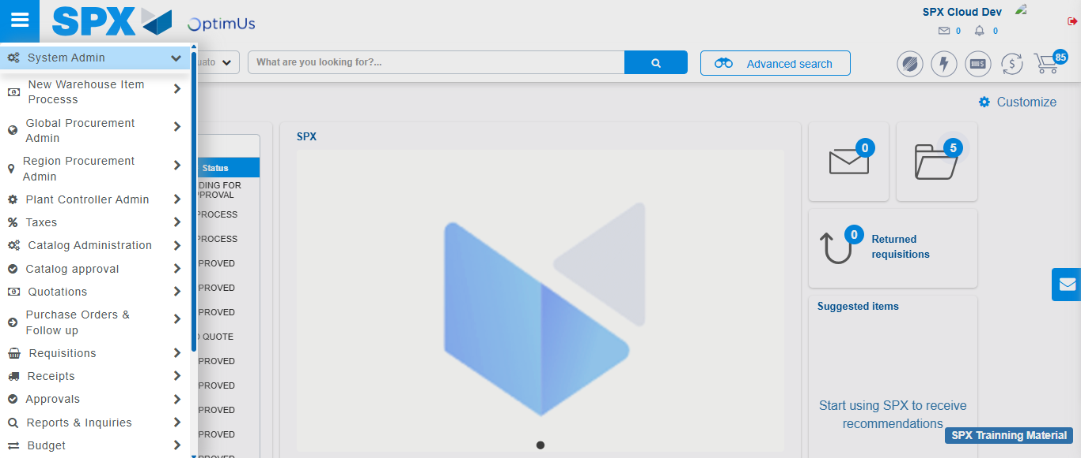Image file-name: QC_Testing-tc006_SPX_Dev5_Validacion_Boton_AddNewMenu_Administrador_Menu-nov. 20 2025, 02 23 38 p. m.

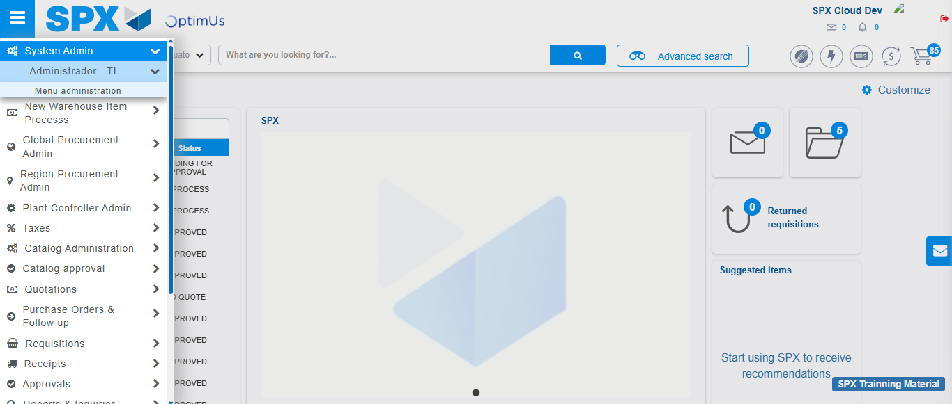Image file-name: QC_Testing-tc006_SPX_Dev5_Validacion_Boton_AddNewMenu_Administrador_Menu-nov. 20 2025, 02 23 39 p. m.

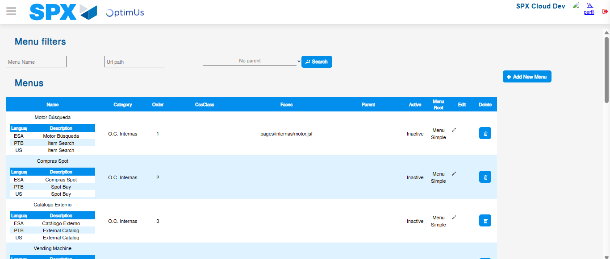Image file-name: QC_Testing-tc006_SPX_Dev5_Validacion_Boton_AddNewMenu_Administrador_Menu-nov. 20 2025, 02 23 40 p. m.

Image file-name: QC_Testing-tc007_SPX_Dev5_Validacion_Boton_Edit_Administrador_Menu-nov. 20 2025, 02 24 00 p. m.

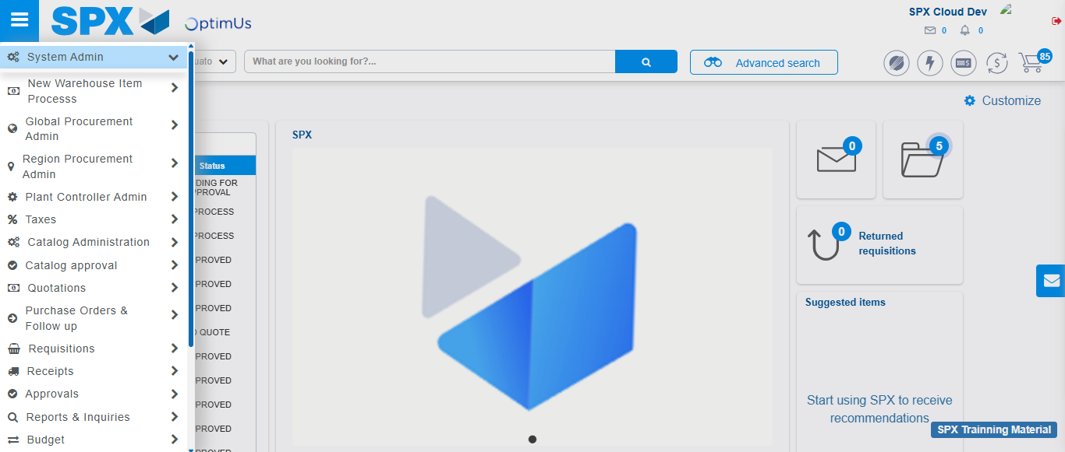Image file-name: QC_Testing-tc007_SPX_Dev5_Validacion_Boton_Edit_Administrador_Menu-nov. 20 2025, 02 24 01 p. m.

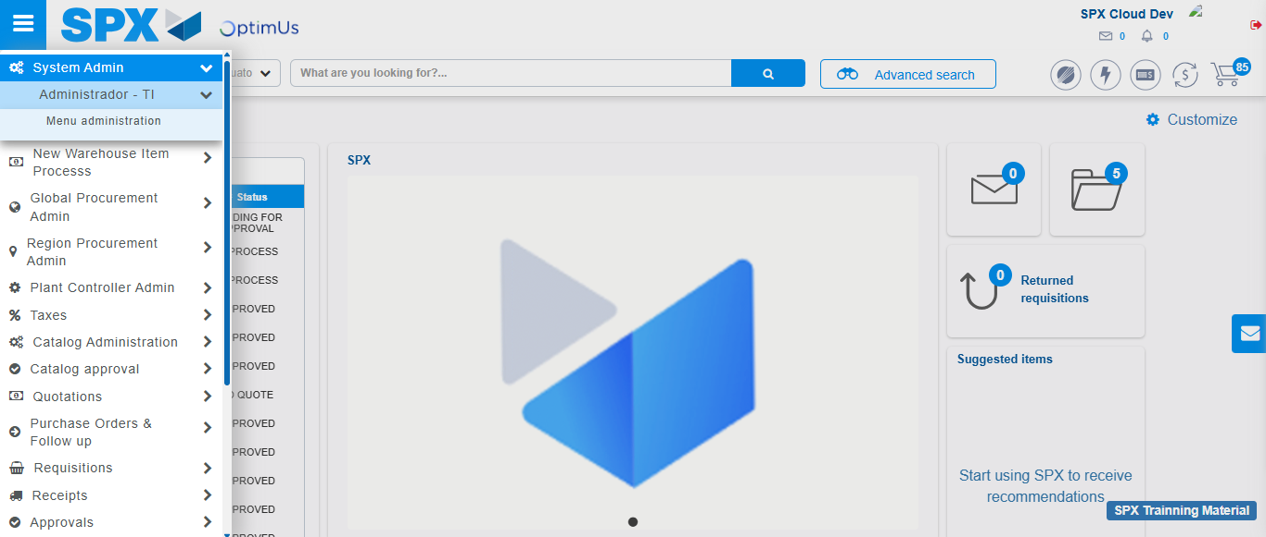Image file-name: QC_Testing-tc007_SPX_Dev5_Validacion_Boton_Edit_Administrador_Menu-nov. 20 2025, 02 24 02 p. m.

Image file-name: QC_Testing-tc007_SPX_Dev5_Validacion_Boton_Edit_Administrador_Menu-nov. 20 2025, 02 24 04 p. m.

Image file-name: QC_Testing-tc008_SPX_Dev5_Validacion_Boton_Remove_Administrador_Menu-nov. 20 2025, 02 24 29 p. m.

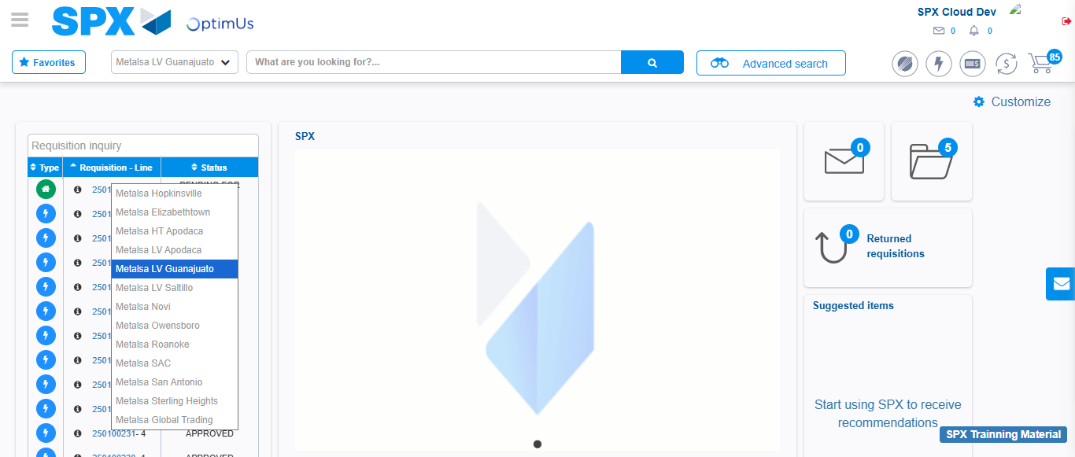Image file-name: QC_Testing-tc008_SPX_Dev5_Validacion_Boton_Remove_Administrador_Menu-nov. 20 2025, 02 24 30 p. m.

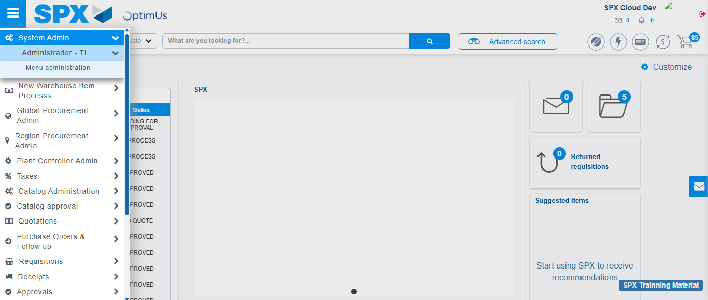Image file-name: QC_Testing-tc008_SPX_Dev5_Validacion_Boton_Remove_Administrador_Menu-nov. 20 2025, 02 24 31 p. m.

Image file-name: QC_Testing-tc008_SPX_Dev5_Validacion_Boton_Remove_Administrador_Menu-nov. 20 2025, 02 24 33 p. m.

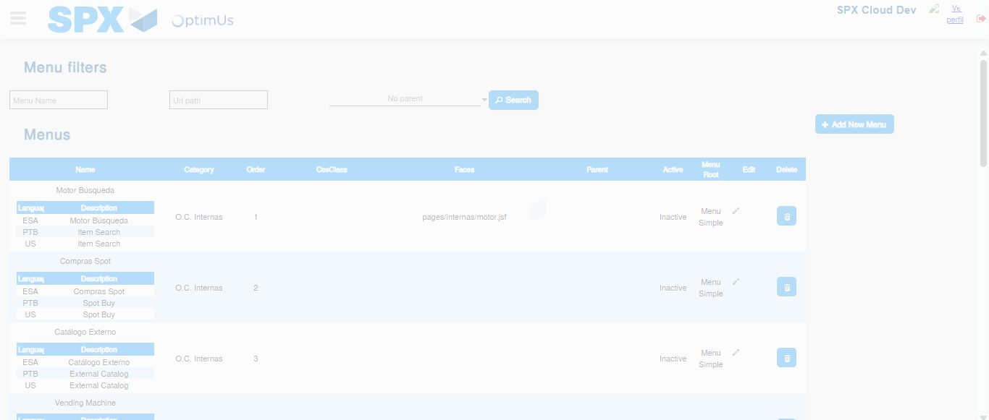Image file-name: QC_Testing-tc008_SPX_Dev5_Validacion_Boton_Remove_Administrador_Menu-nov. 20 2025, 02 24 34 p. m.

Image file-name: QC_Testing-tc009_SPX_Dev5_Validacion_Campos_Busqueda_Articulos_Controlados-nov. 20 2025, 02 24 54 p. m.

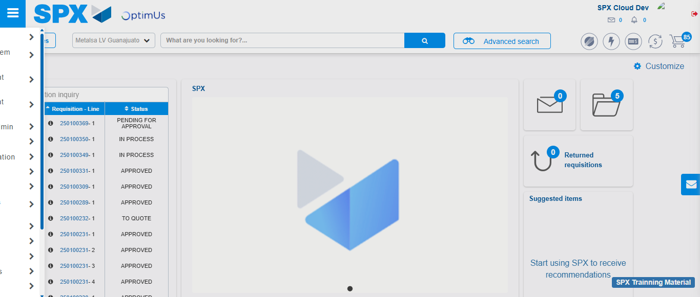Image file-name: QC_Testing-tc009_SPX_Dev5_Validacion_Campos_Busqueda_Articulos_Controlados-nov. 20 2025, 02 24 55 p. m.

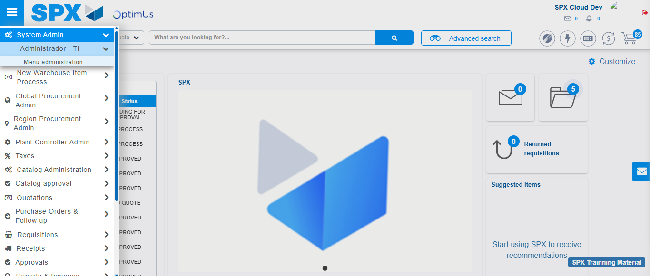Image file-name: QC_Testing-tc009_SPX_Dev5_Validacion_Campos_Busqueda_Articulos_Controlados-nov. 20 2025, 02 24 56 p. m.

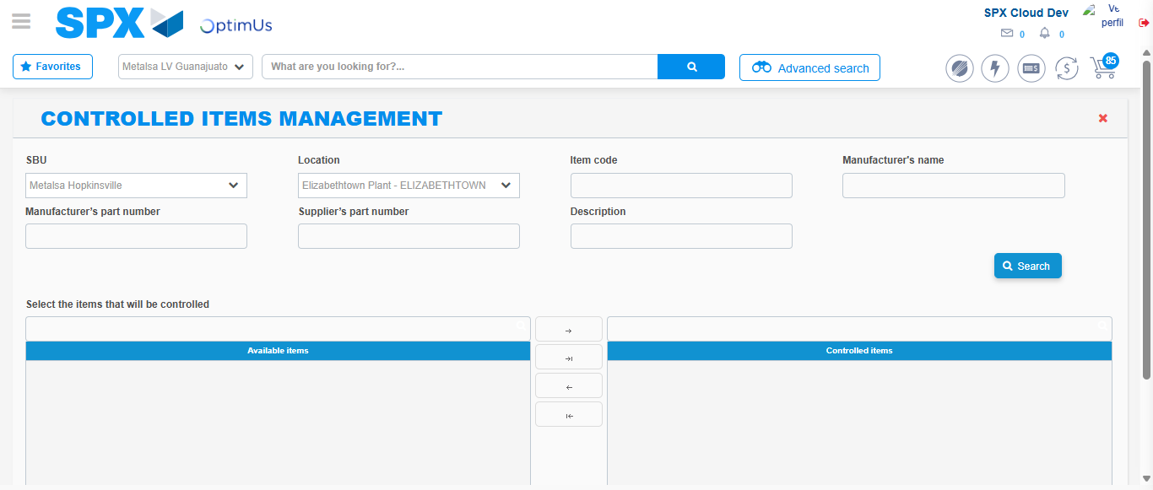Image file-name: QC_Testing-tc009_SPX_Dev5_Validacion_Campos_Busqueda_Articulos_Controlados-nov. 20 2025, 02 24 59 p. m.

Image file-name: QC_Testing-tc010_SPX_Dev5_Validacion_Agregar_Remover_Articulos_Controlados-nov. 20 2025, 02 25 40 p. m.

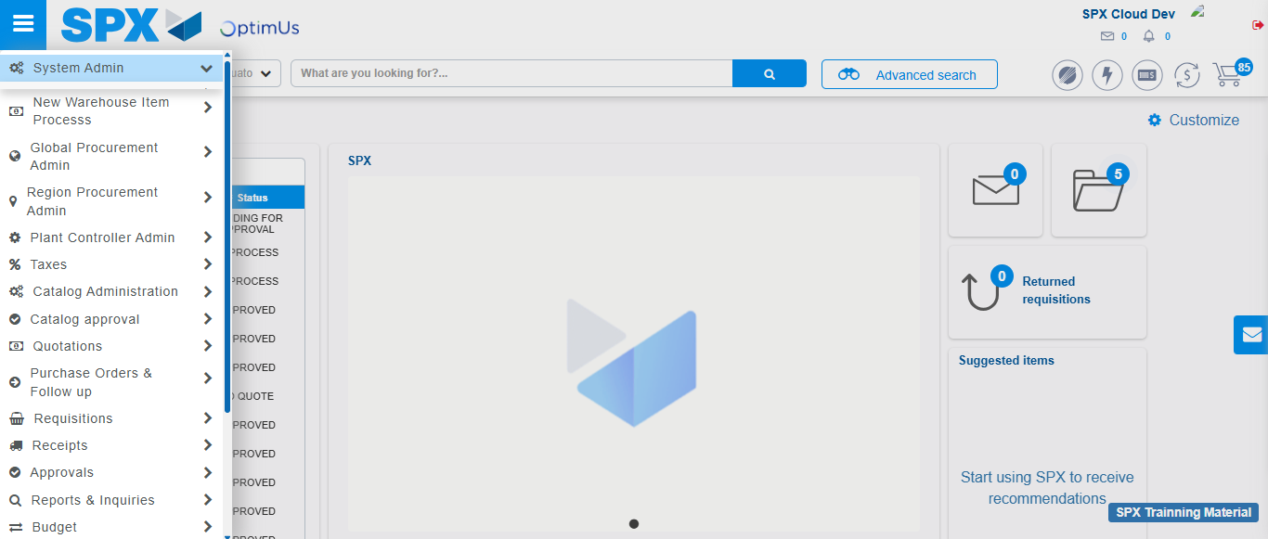Image file-name: QC_Testing-tc010_SPX_Dev5_Validacion_Agregar_Remover_Articulos_Controlados-nov. 20 2025, 02 25 41 p. m.

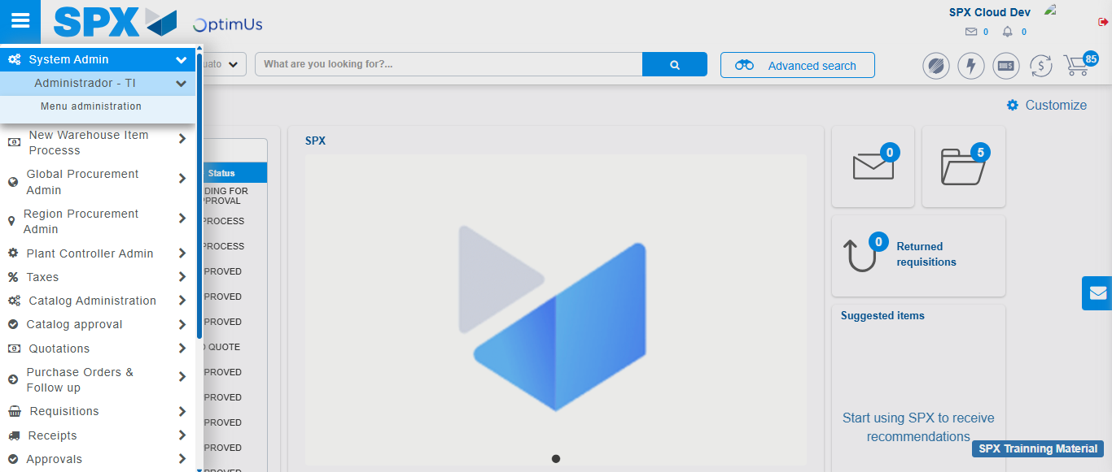Image file-name: QC_Testing-tc010_SPX_Dev5_Validacion_Agregar_Remover_Articulos_Controlados-nov. 20 2025, 02 25 42 p. m.

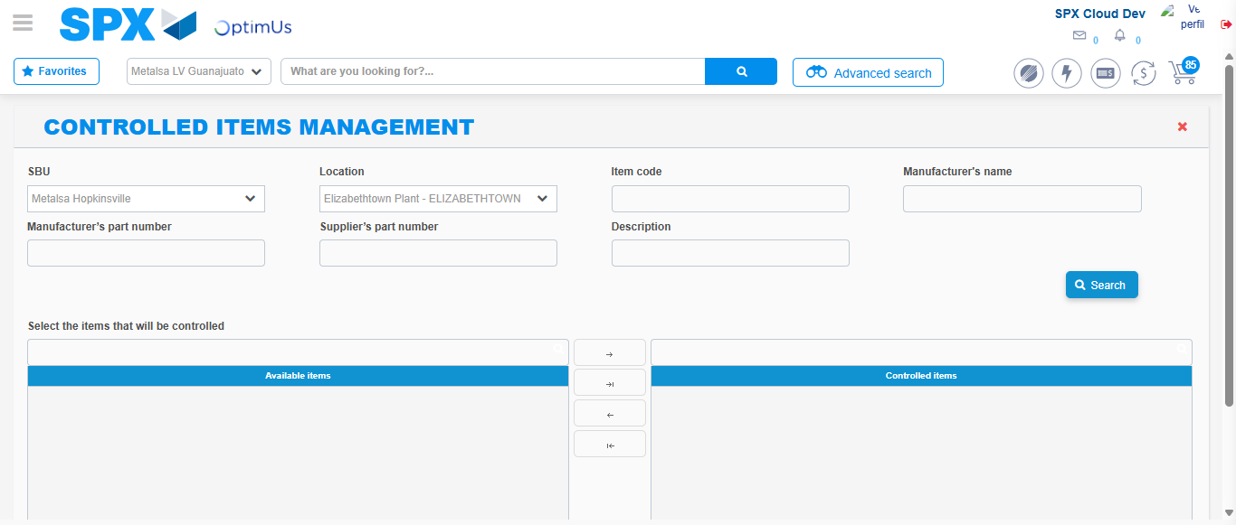Image file-name: QC_Testing-tc010_SPX_Dev5_Validacion_Agregar_Remover_Articulos_Controlados-nov. 20 2025, 02 25 44 p. m.

Step 3 - Validation buttons Add & Remove: Correct buttons validation
Image file-name: QC_Testing-tc009_SPX_Dev5_Validacion_Campos_Busqueda_Articulos_Controlados-nov. 20 2025, 02 24 59 p. m.

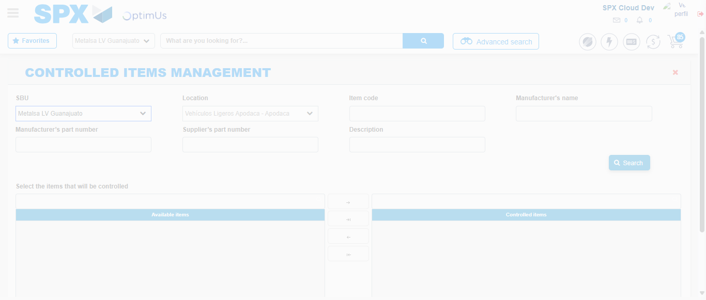Image file-name: QC_Testing-tc009_SPX_Dev5_Validacion_Campos_Busqueda_Articulos_Controlados-nov. 20 2025, 02 25 00 p. m.

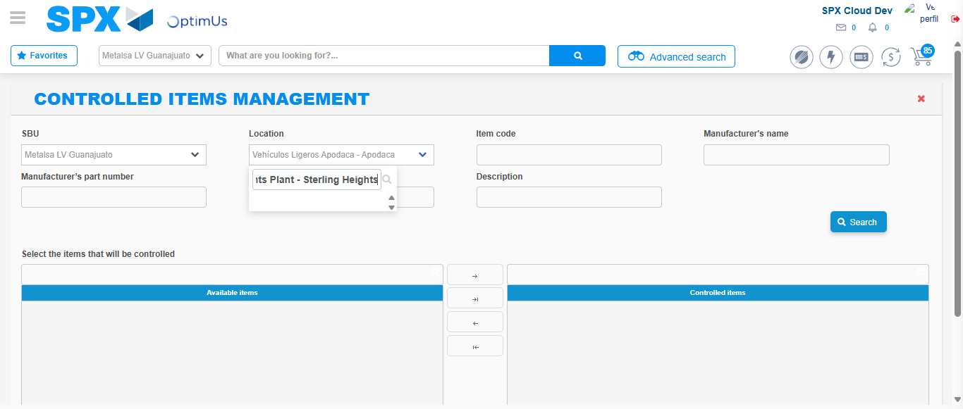Image file-name: QC_Testing-tc009_SPX_Dev5_Validacion_Campos_Busqueda_Articulos_Controlados-nov. 20 2025, 02 25 01 p. m.

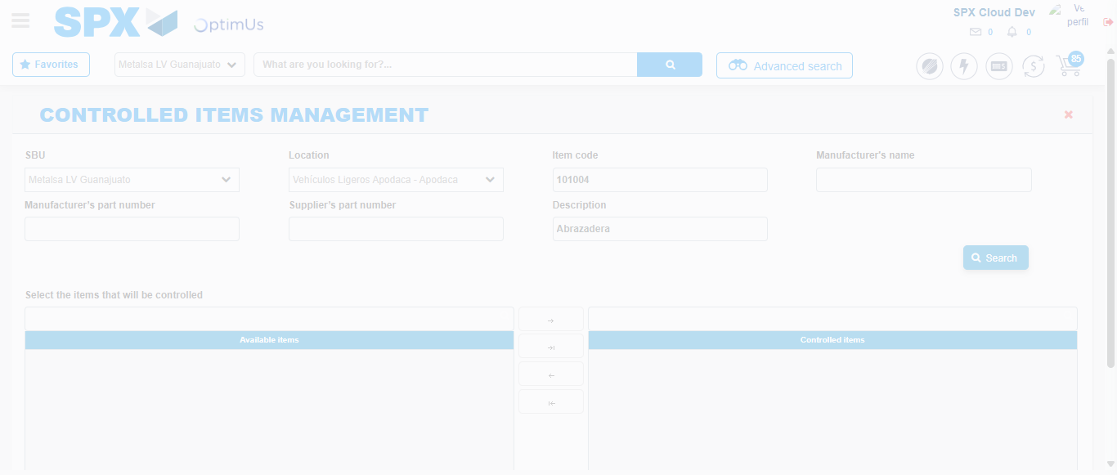Image file-name: QC_Testing-tc009_SPX_Dev5_Validacion_Campos_Busqueda_Articulos_Controlados-nov. 20 2025, 02 25 12 p. m.

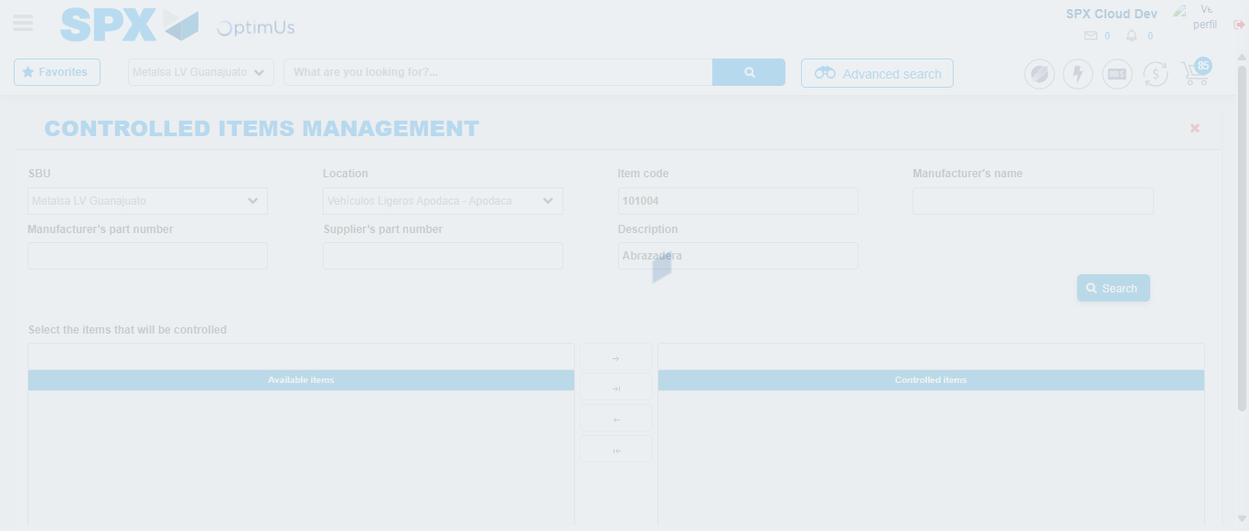Image file-name: QC_Testing-tc009_SPX_Dev5_Validacion_Campos_Busqueda_Articulos_Controlados-nov. 20 2025, 02 25 13 p. m.

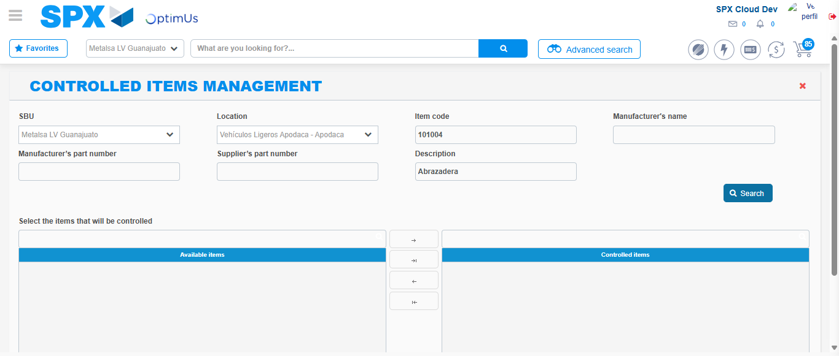Image file-name: QC_Testing-tc009_SPX_Dev5_Validacion_Campos_Busqueda_Articulos_Controlados-nov. 20 2025, 02 25 23 p. m.

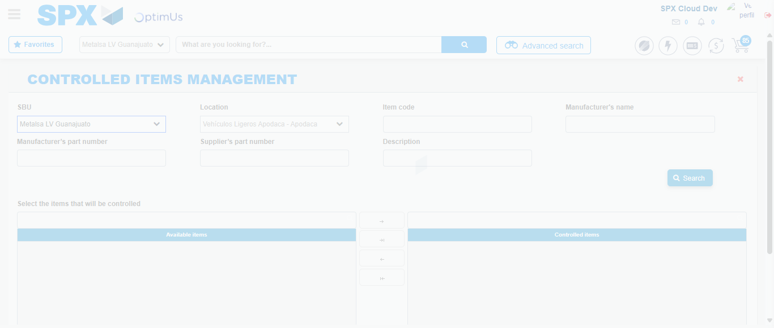Image file-name: QC_Testing-tc010_SPX_Dev5_Validacion_Agregar_Remover_Articulos_Controlados-nov. 20 2025, 02 25 45 p. m.

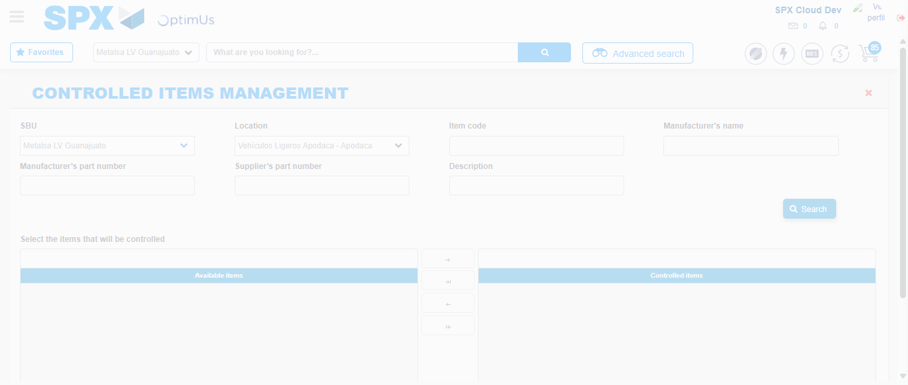Image file-name: QC_Testing-tc010_SPX_Dev5_Validacion_Agregar_Remover_Articulos_Controlados-nov. 20 2025, 02 25 46 p. m.

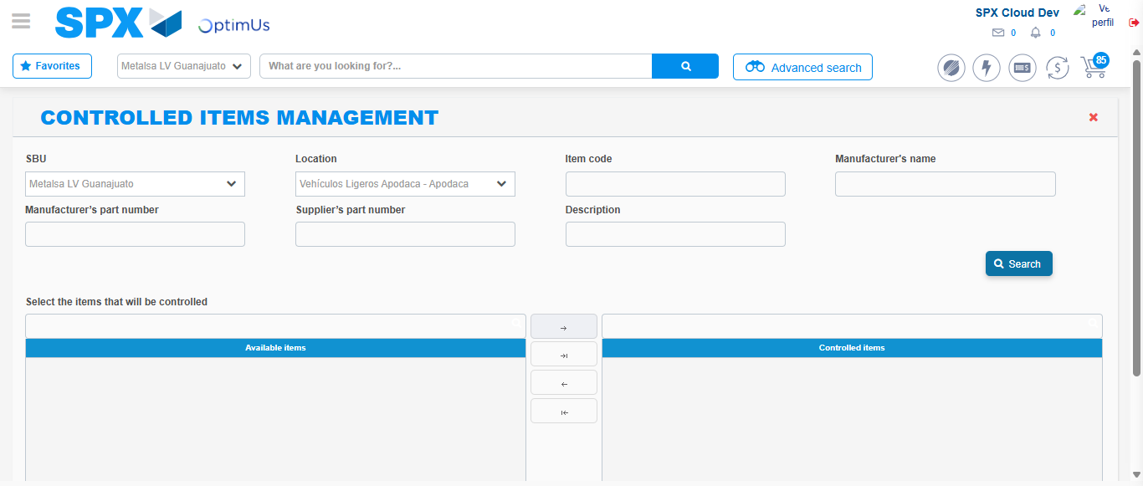Image file-name: QC_Testing-tc010_SPX_Dev5_Validacion_Agregar_Remover_Articulos_Controlados-nov. 20 2025, 02 25 57 p. m.

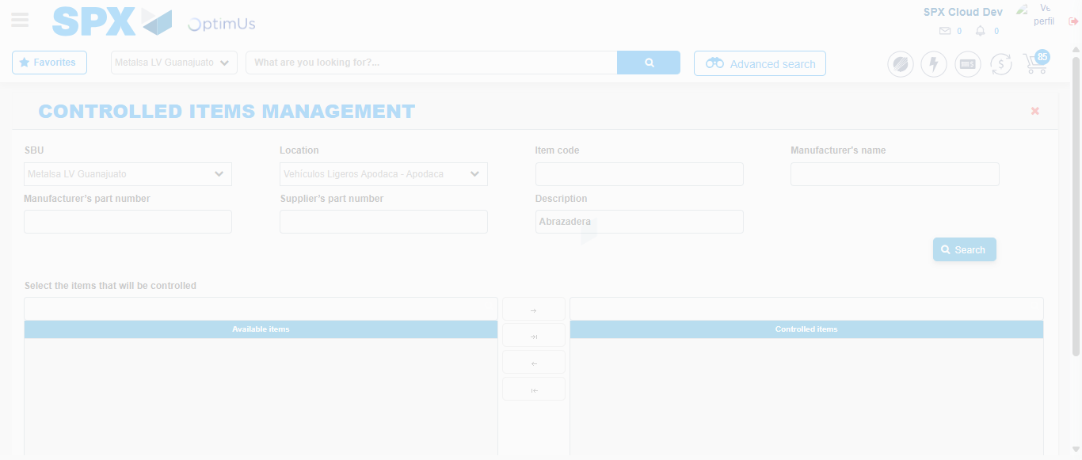Image file-name: QC_Testing-tc010_SPX_Dev5_Validacion_Agregar_Remover_Articulos_Controlados-nov. 20 2025, 02 26 11 p. m.

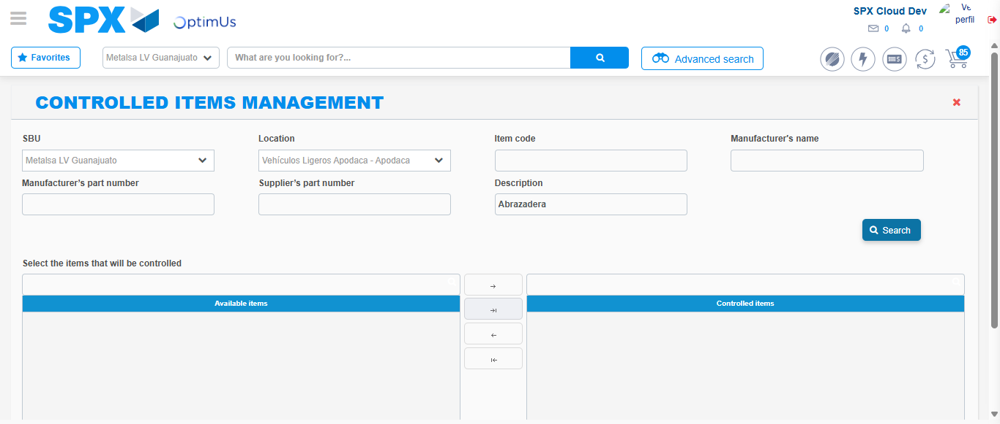Image file-name: QC_Testing-tc010_SPX_Dev5_Validacion_Agregar_Remover_Articulos_Controlados-nov. 20 2025, 02 26 14 p. m.

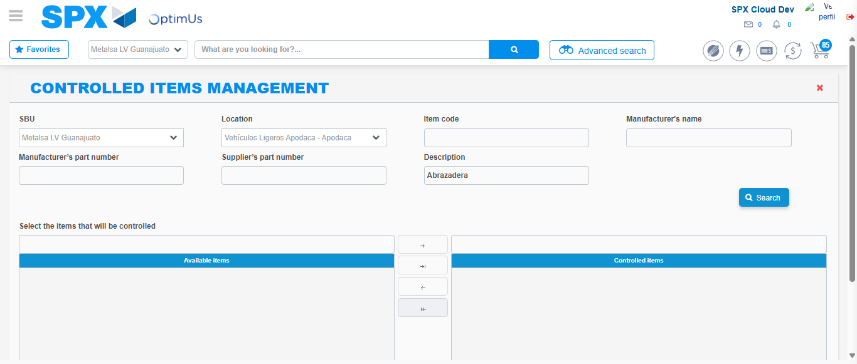Image file-name: QC_Testing-tc010_SPX_Dev5_Validacion_Agregar_Remover_Articulos_Controlados-nov. 20 2025, 02 26 18 p. m.

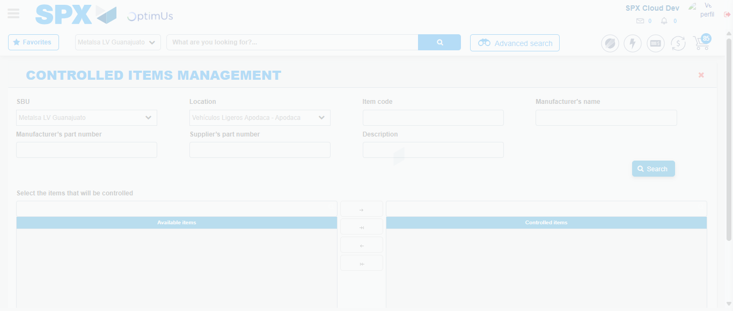Image file-name: QC_Testing-tc010_SPX_Dev5_Validacion_Agregar_Remover_Articulos_Controlados-nov. 20 2025, 02 26 21 p. m.

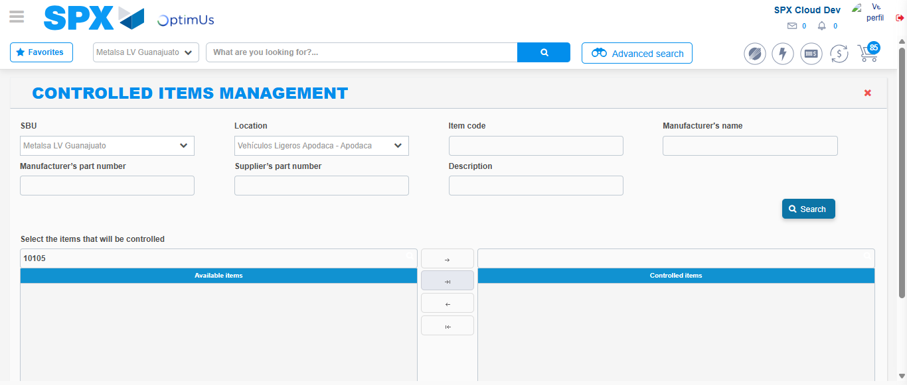Image file-name: QC_Testing-tc010_SPX_Dev5_Validacion_Agregar_Remover_Articulos_Controlados-nov. 20 2025, 02 26 25 p. m.

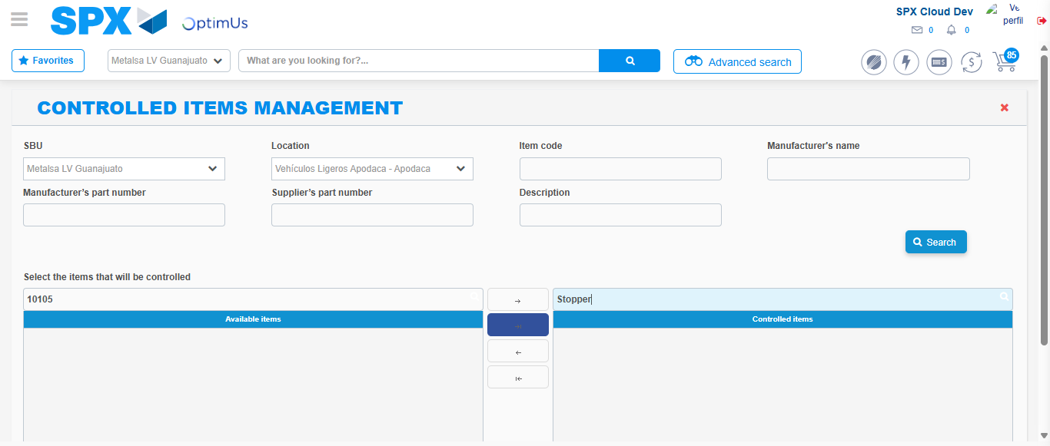Image file-name: QC_Testing-tc010_SPX_Dev5_Validacion_Agregar_Remover_Articulos_Controlados-nov. 20 2025, 02 26 28 p. m.

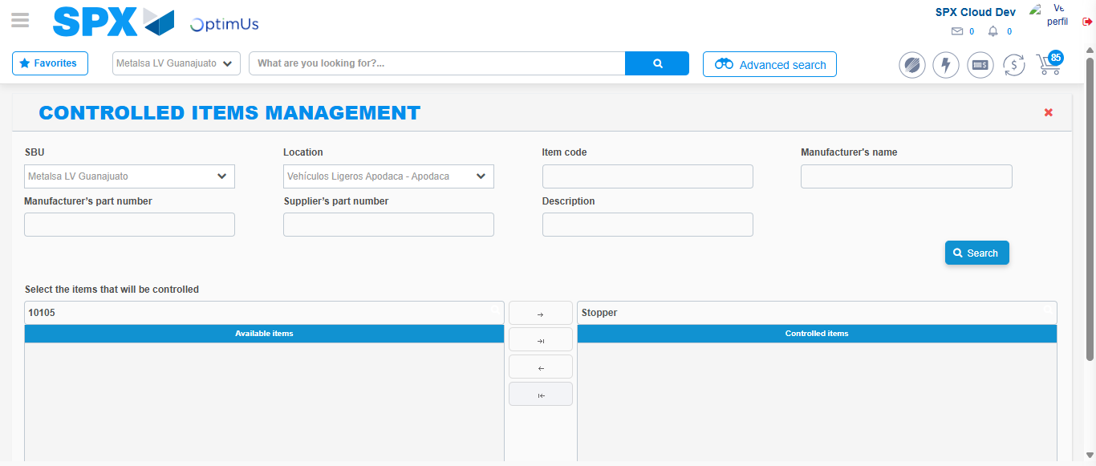Image file-name: QC_Testing-tc010_SPX_Dev5_Validacion_Agregar_Remover_Articulos_Controlados-nov. 20 2025, 02 26 29 p. m.

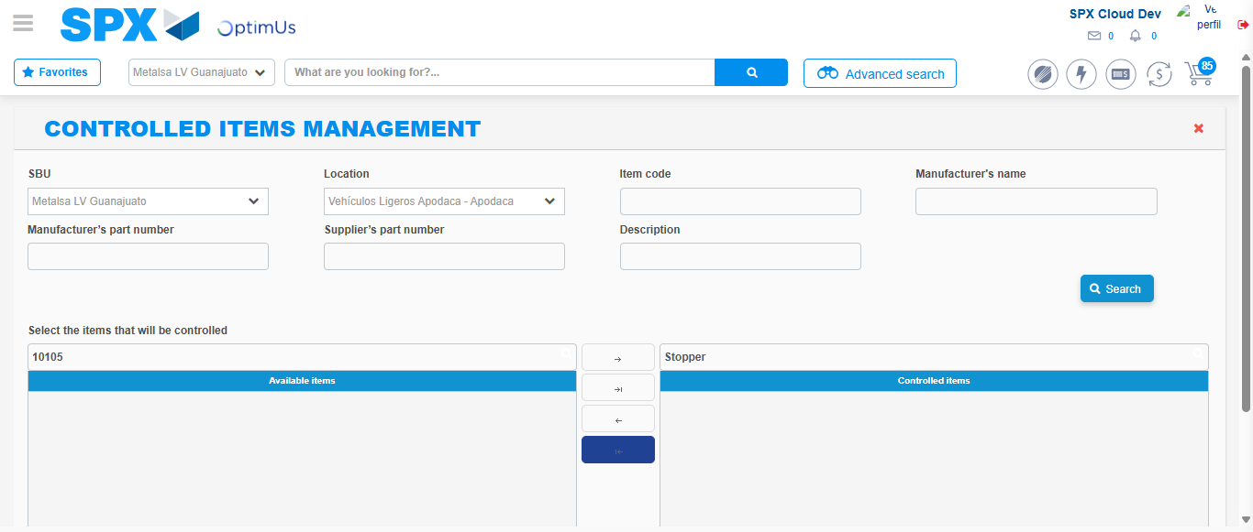Image file-name: QC_Testing-tc010_SPX_Dev5_Validacion_Agregar_Remover_Articulos_Controlados-nov. 20 2025, 02 26 32 p. m.

